

K.R. Mangalam University
School of Engineering & Technology

DATA STRUCTURE
Lab File

Submitted by: Submitted to:
Kashish Sharma Dr. Swati Gupta
2401420039
Btech-CSE (Data Science)
INDEX

S. No. | Experiment Title | Page No.
1 | Browser History Navigation System (Using Stack Concept) | 3 – 10
2 | Ticketing System Using Queue (Linear Queue Implementation) | 10 – 15
3 | Singly Linked List Operations (Insert, Delete, Search, Display) | 16 – 21
4 | Circular Singly Linked List (Insert, Search, Delete, Display) | 22 – 28
5 | Reverse a String Using Stack | 29 – 30
6 | Check Balanced Parentheses Using Stack | 31 – 33
7 | Lab Project: Inventory Stock Management System | 34 – 45

LAB EXPERIMENT 01
Browser History Navigation System (Using Stack Concept)

1. Problem Statement
Create a Python program that models how a web browser handles movement between webpages.
The user should be able to open a new webpage, return to a previous one, move forward again, check the current browsing trail, see the full browsing log, and view page-visit statistics.

2. Objective
To develop a browser-like navigation system using Python data structures.
• To apply stack operations to manage backward and forward page movement.
• To maintain a complete visit log that records every page the user opens.
• To analyze the browsing pattern by calculating how many times each page was visited.
• To create a user-friendly, menu-based program that allows smooth interaction.

3. Description
- A browser uses two stacks to manage navigation: one for going back and one for going forward.
- Opening a new page adds it to the back stack and clears the forward stack.
- Using “Back” moves the current page to the forward stack and shows the previous page.
- Using “Forward” brings a page back from the forward stack to the back stack.
- The program recreates this behaviour using:
- Back stack for previously visited pages,
- Forward stack for pages you can revisit,
- Total history list for recording every visit.
This structure demonstrates how stack operations form the core of browser navigation.
4. Algorithm
- Initialize Data Structures -
  - Create an empty Back Stack (stores previous pages).
  - Create an empty Forward Stack (stores pages you can move forward to).
  - Create an empty History List (stores all visited pages).
  - Set current_page = None.
- Open a New Webpage -
  - If current_page is not None, push it onto Back Stack.
  - Set current_page = new_page.
  - Clear the Forward Stack (because a new navigation breaks the forward chain).
  - Add new_page to History List.
- Go Back -
  - If Back Stack is empty → display “No previous page”.
  - Else:
    - Push current_page onto Forward Stack.
    - Pop top page from Back Stack → assign it to current_page.
- Go Forward -
  - If Forward Stack is empty → display “No forward page”.
  - Else:
    - Push current_page onto Back Stack.
    - Pop top page from Forward Stack → assign it to current_page.
- Show Current Browsing Path -
  - Print contents of:
    - Back Stack
    - current_page
    - Forward Stack
- Show Full Browsing History -
  - Print all elements in History List.
- Show Page Visit Count -
  - Create a dictionary/map.
  - For every page in History List, increment its counter.
  - Display each page with number of times it was visited.
- Menu Loop -
  - Continuously show the menu:
    - Open Page
    - Back
    - Forward
    - Show Path
    - Show History
    - Show Visit Stats
    - Exit
  - Accept user choice.
  - Call appropriate function.

5. Program Code -
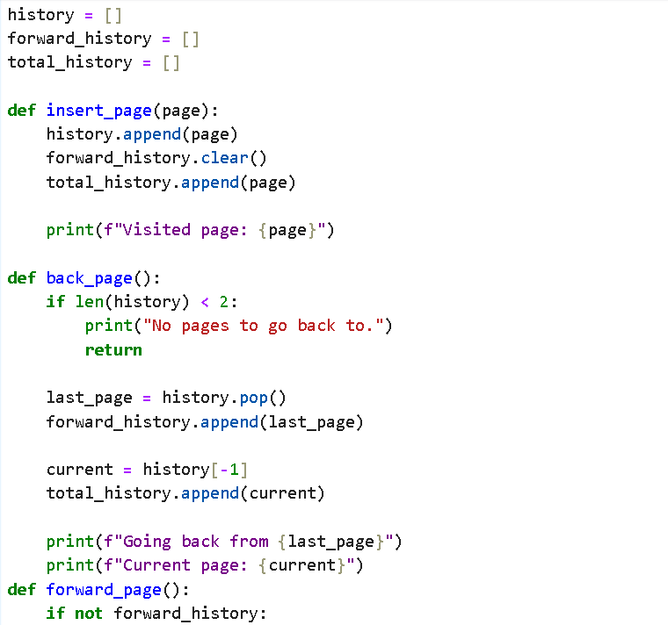

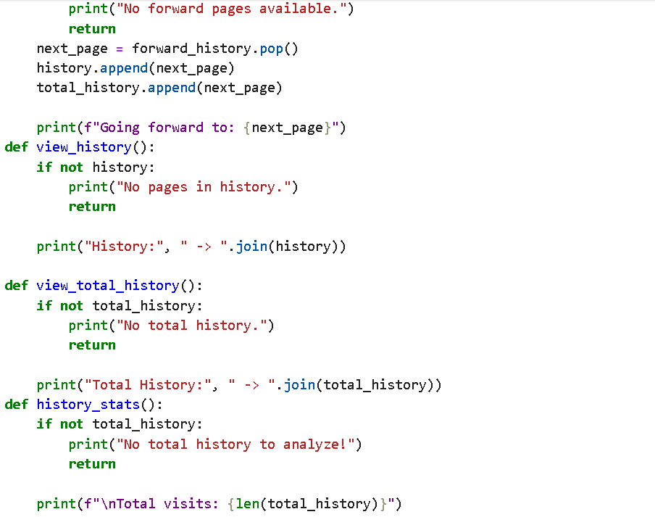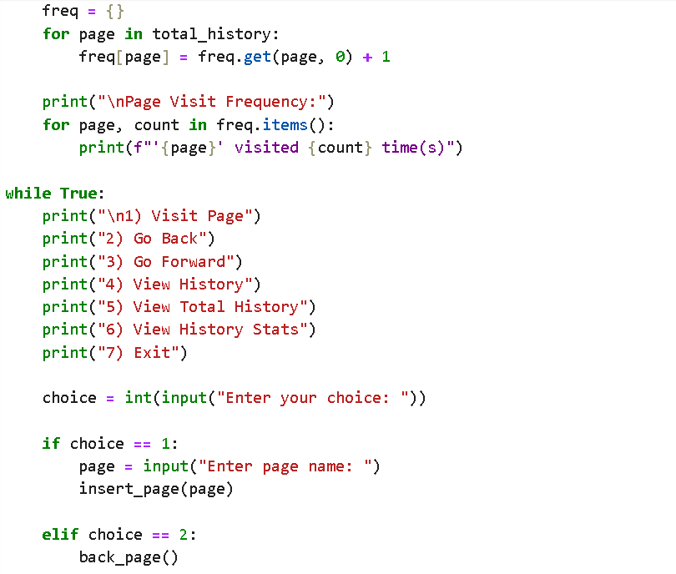
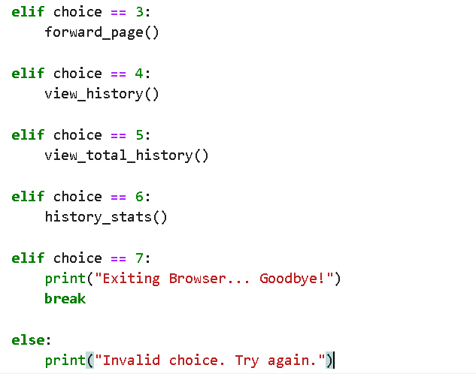

6. Sample Output
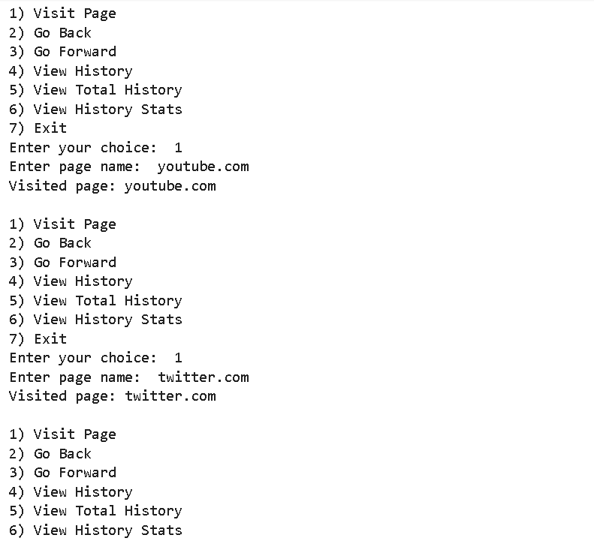
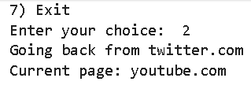
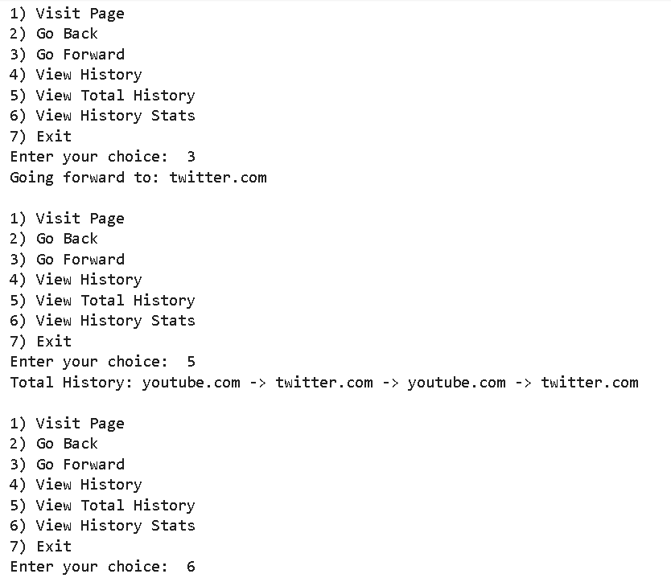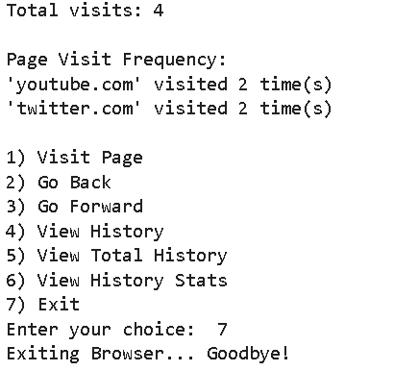

7.Time Complexities
Operation | Complexity
Visit Page | O(1)
Back | O(1)
Forward | O(1)
View History | O(n)
History Stats | O(n)
5
8. Conclusion
This provides a clear and practical understanding of how a web browser manages webpage navigation using simple data structures. By simulating the back stack, forward stack, and total browsing log, the program shows how everyday browser actions—like opening a page, going back, or moving forward—are actually handled internally. The simulation also highlights how efficient stack operations make navigation feel instant, while tasks that involve scanning the whole history naturally take more time. Overall, the project demonstrates how fundamental concepts in data structures translate directly into real-world applications, making the learning experience both meaningful and relatable.

LAB EXPERIMENT 02
Ticketing System Using Queue (Implementation of Linear Queue)

1. Problem Statement
Design a Python program that represents a basic ticket-handling system using a queue.
The program should let users add new tickets, process or remove tickets, display the current queue, check how many tickets are waiting, and handle situations where the queue becomes full or empty.
2. Objective
- To implement a ticketing system using the queue data structure in Python.
- To understand how FIFO (First-In, First-Out) operations work in real applications.
- To allow users to add and remove tickets in a controlled manner.
- To display all pending tickets and monitor the current queue size.
- To detect and handle overflow (queue is full) and underflow (queue is empty) conditions effectively.
- To build an easy-to-use, menu-driven program that demonstrates practical queue operations.

3. Description
A queue is a linear structure that works on the FIFO (First In, First Out) rule.
This means the item added first is also the first one to be taken out—just like people standing in a line.
In this ticketing system:
- The queue is built using a fixed-size Python list.
- front points to the first active ticket in the queue.
- rear shows the position where the next ticket will be placed.
- enqueue() adds a new ticket at the rear end.
- dequeue() removes the ticket currently at the front.
Special conditions:
- Overflow: Occurs when rear == MAX - 1, meaning no more tickets can be added.
- Underflow: Occurs when the queue has no elements (front > rear or front == -1).
This setup reflects real-life situations like ticket counters, service lines, or customer queues.

- Algorithm –
- Initialize
- Set MAX as the maximum size of the queue.
- Create a list queue of size MAX.
- Set front = -1 and rear = -1.

- Enqueue (Add Ticket)
- Check if rear == MAX - 1
→ If true, print “Overflow – No more tickets can be added.”
- Else:
  - If front == -1, set front = 0 (first ticket).
  - Increase rear by 1.
  - Insert the new ticket at queue[rear].
  - Print confirmation message.

- Dequeue (Remove Ticket)
- Check if front == -1 OR front > rear
→ If true, print “Underflow – No tickets to remove.”
- Else:
  - Remove the ticket at queue[front].
  - Increase front by 1.
  - If front > rear, reset both to -1 (queue becomes empty).
  - Print which ticket was removed.

- View Queue
- If queue is empty (front == -1), print “Queue is empty.”
- Else print all elements from front to rear.

- Check Queue Size
- If queue is empty → size is 0.
- Else → size = rear - front + 1.
- Display the size.

- Exit
Stop the program.

- Program Code

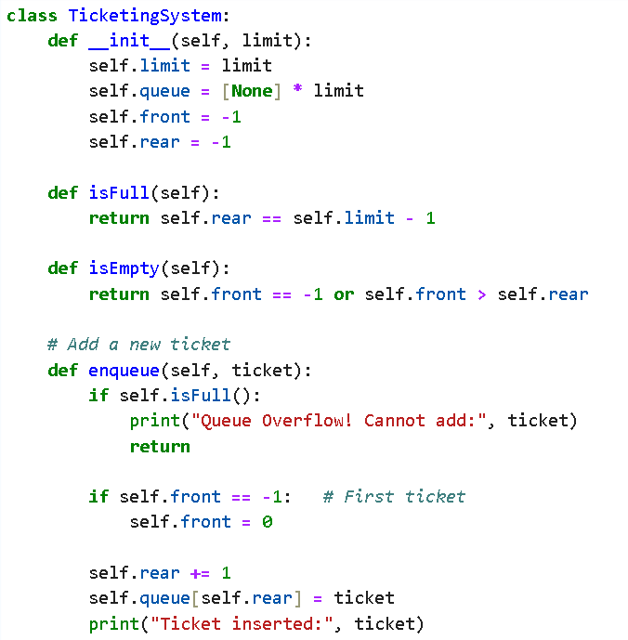
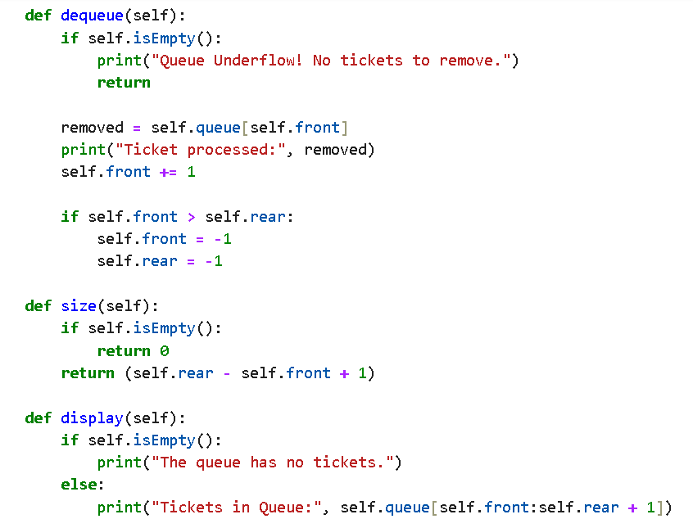
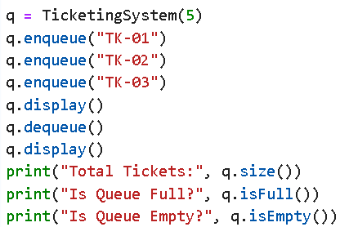

6. Sample Output
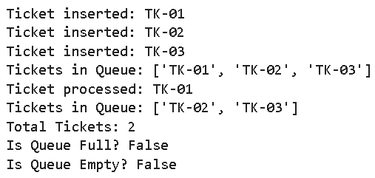

7. Time Complexities
- Enqueue → O(1)
- Dequeue → O(1)
- Size → O(1)
- Display → O(n)
Applications
- Used in ticket counters to serve people in order.
- Used in CPU scheduling for managing processes.
- Used in printers to handle print jobs sequentially.
- Used in call centres to queue incoming calls.

8. Observations / Conclusion
The ticketing system effectively demonstrates how a queue operates by adding and removing tickets in a FIFO manner. It shows how real-world lines are managed and handles both empty and full queue situations. The program makes queue operations easy to visualize and highlights their importance in everyday systems.

LAB EXPERIMENT 03
Singly Linked List Operations (Insertion, Deletion, Search, Display)

1. Problem Statement
Create a Python program that implements a singly linked list and supports essential operations.
These operations should include inserting nodes at the beginning, end, and a specific position; deleting nodes from the beginning and end; searching for a given value and displaying all elements of the list.
2. Objective
- To implement a singly linked list using Python classes and nodes.
- To perform basic list operations like insertion, deletion, search, and traversal.
- To understand how dynamic data structures work without fixed memory size.
- To learn how nodes are linked through pointers in linear order.

3. Description
A linked list is a dynamic linear data structure where each element (node) contains:
- Element / Data
- Link / Pointer to the next node
The first node is called the Start (Head).
Unlike arrays, linked lists do not store elements in contiguous memory, making insertions and deletions more efficient (no shifting required).
This program implements:
Node structure 11
| Element | Link → next node |
Supported operations:
- Insert at beginning
- Insert at end
- Insert at a given position
- Search for an element
- Delete from beginning
- Delete from end
- Display list
This experiment helps understand self-referential structures and pointer-like behaviour in Python.

5. Algorithm
- Insert at Beginning
- Create a new node.
- Point its Link to current Start.
- Update Start to new node.
- Insert at End
- Create a new node.
- If list empty → new node becomes Start.
- Otherwise traverse to last node and link it to new node.
- Insert at Middle
- If position = 1 → insert at beginning.
- Traverse until position − 1.
- Insert new node in between nodes. 12
- If position exceeds length → append at end.
- Search
- Traverse from Start.
- Compare each node’s element with key.
- Return result.
- Delete from Beginning
- If list empty → print error.
- Move Start to next node.
- Delete from End
- If list empty → error.
- If only one node → set Start to None.
- Otherwise find second-last node and set its link to None.
- Display
- Traverse from Start.
- Print each node until None.
5.Program Code –

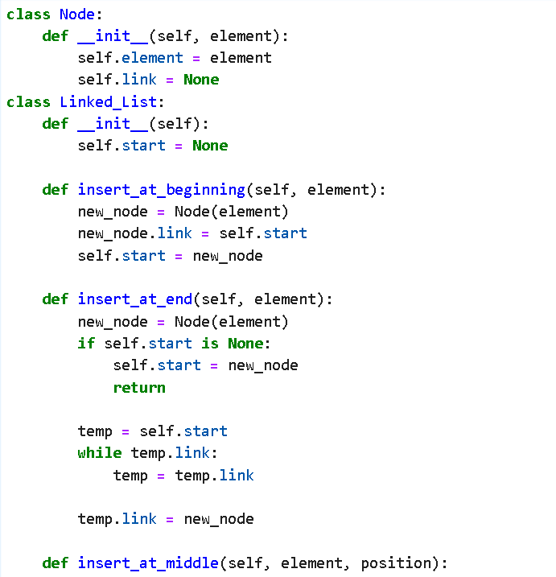

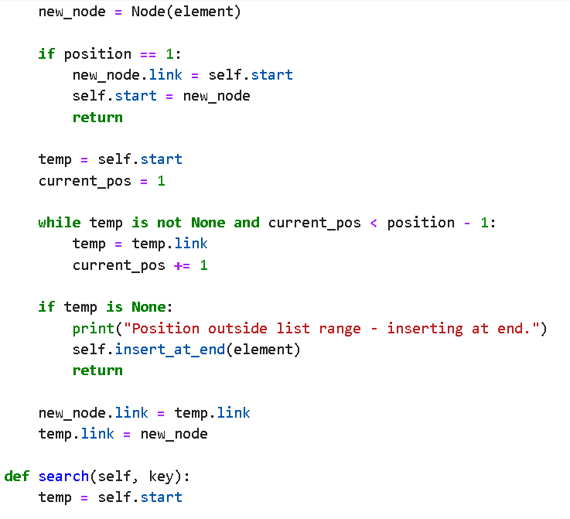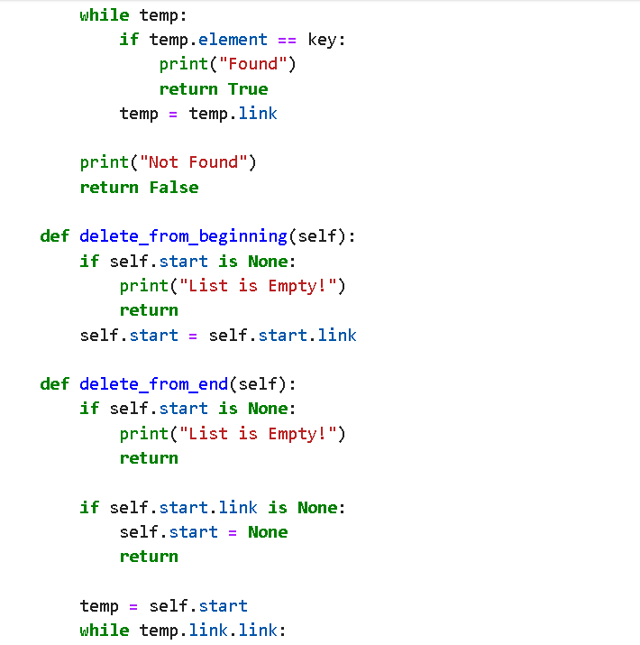
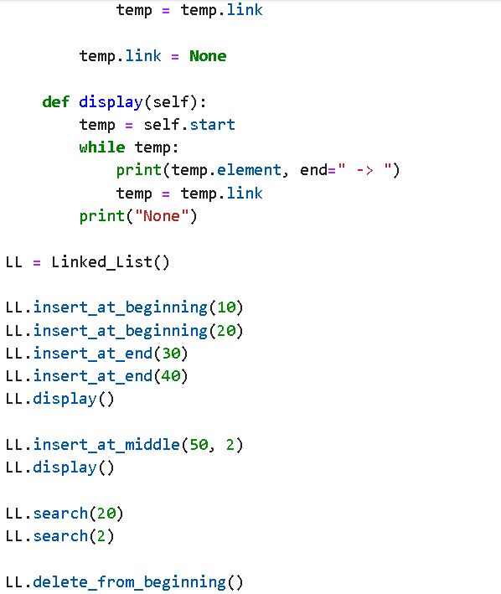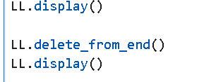

6. Sample Output
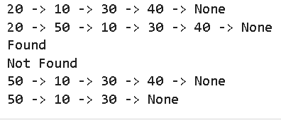

7. Time Complexities
Operation | Complexity
Insert (begin/end) | O (1) / O(n)
Insert at position | O(n)
Delete (begin/end) | O (1) / O(n)
Search | O(n)
Display | O(n)

8. Conclusion
This program successfully demonstrates how a singly linked list works by implementing essential operations such as insertion, deletion, searching, and displaying elements. Through these functions, it becomes easy to understand how nodes are linked and manipulated in memory. The code shows how dynamic data structures offer flexibility compared to arrays, making linked lists a useful concept in real-world applications.

LAB EXPERIMENT 04
Circular Singly Linked List (Insert, Search, Delete, Display)

1. Problem Statement
Create a Python program that builds and manages a Circular Singly Linked List. The program should allow the user to insert nodes at the beginning, in the middle (after a chosen position), and at the end of the list. It must also support deleting nodes from both the front and the rear, searching for a specific value in the list, and displaying all elements while maintaining the circular connection between nodes.
2. Objective
- To learn how a Circular Singly Linked List works.
- To implement insertion at the start, middle, and end.
- To delete nodes from the beginning and end.
- To search and display elements while keeping the list circular.
3. Description
A Circular Singly Linked List is a linked structure where the last node points back to the first, forming a continuous loop.
In this program, nodes can be added at the beginning, in the middle, or at the end, and they can also be removed from both ends.
The list supports searching for an element and displaying all nodes while maintaining the circular connection.
This structure is useful in applications that require repeated or cyclic traversal.

4. Algorithm
- Insert at Beginning
- Create a new node.
- If the list is empty, point the new node to itself and make it the head.
- Else, traverse to the last node.
- Link the new node to head and update last node’s link to the new node.
- Update head to the new node.
- Insert at End
- Create a new node.
- If the list is empty, point the new node to itself and set it as head.
- Else, traverse to the last node.
- Link the last node to the new node and the new node back to head.
- Insert at Middle (after a given position)
- Create a new node.
- Traverse the list until the given position is reached.
- Link the new node to the next node.
- Update the previous node’s link to the new node.
- Delete from Beginning
- If the list is empty, print underflow.
- If only one node exists, set head to None.
- Else, traverse to the last node.
- Update head to the next node and link last node to new head.
- Delete from End
- If the list is empty, print underflow.
- If only one node exists, set head to None.
- Else, traverse to the second-last node.
- Set its link to head, removing the last node.
- Search an Element
- Start from head.
- Traverse node by node until the element is found or loop completes.
- Return found/not found message.
- Display List
- If empty, print “List is empty.”
- Else start at head and print each node.
- Stop when you reach head again.

5. Program Code -
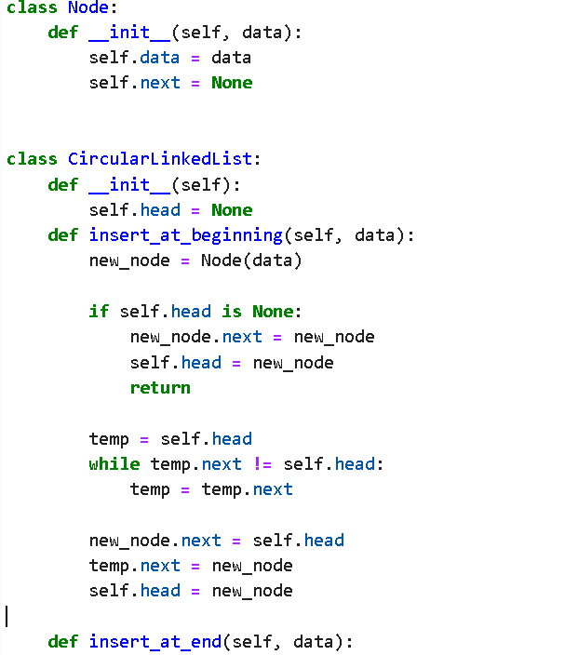
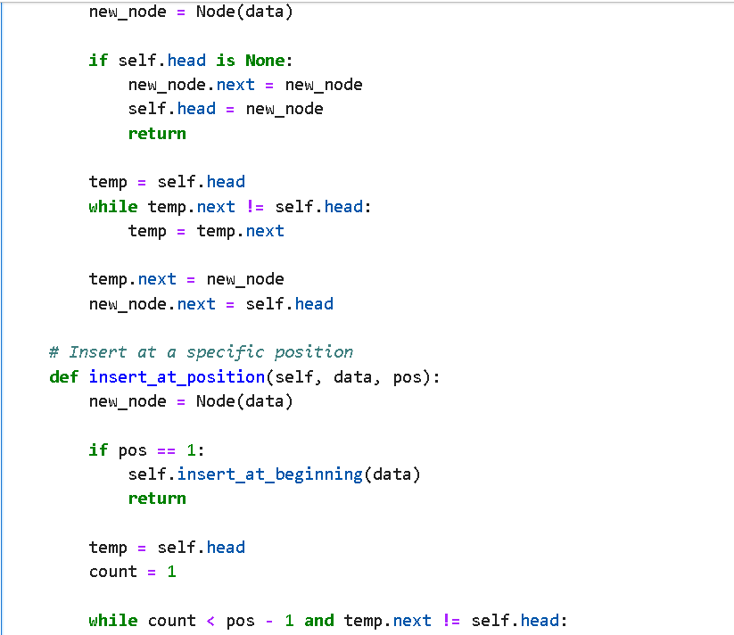

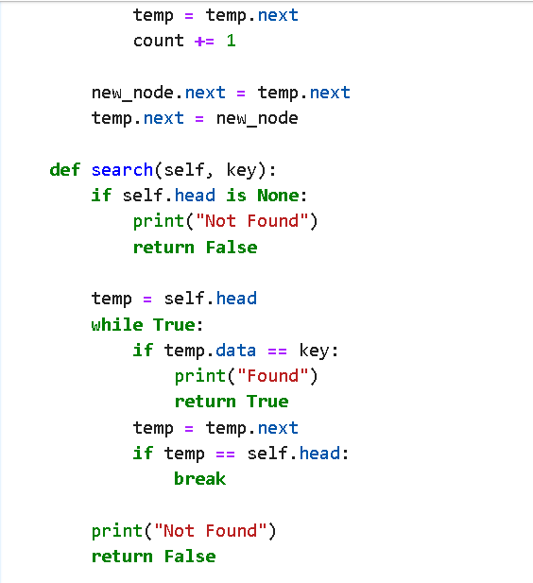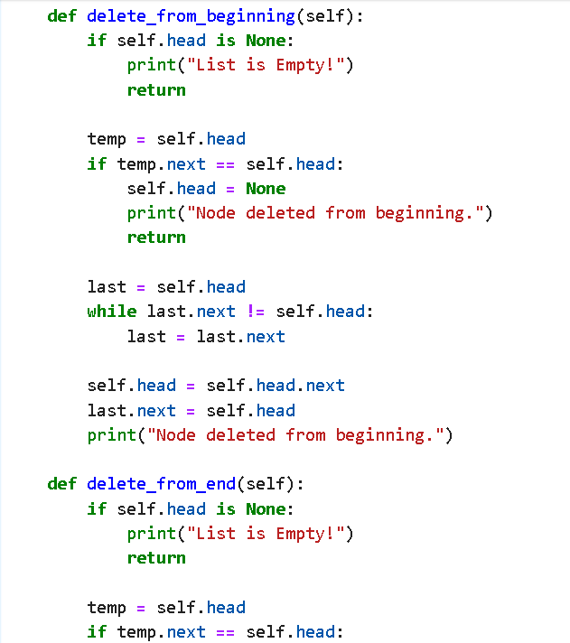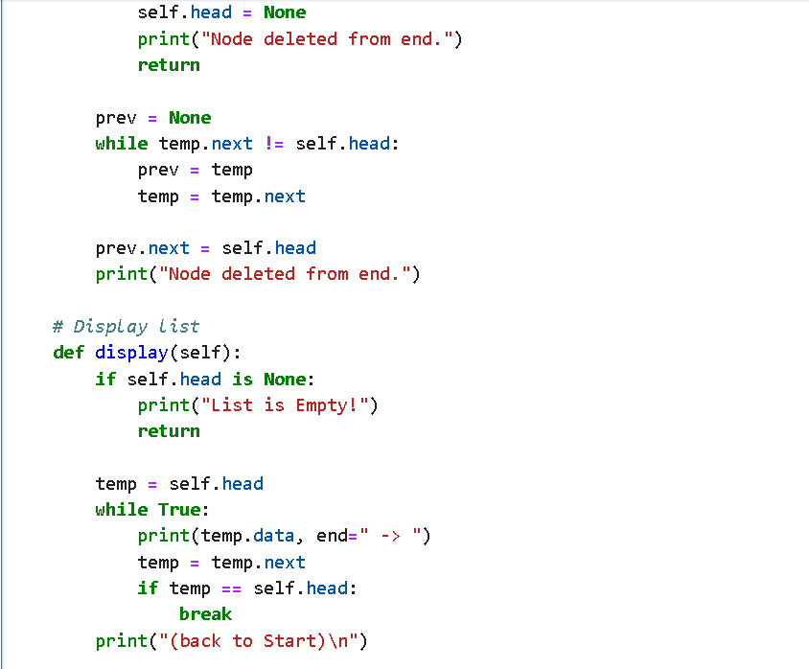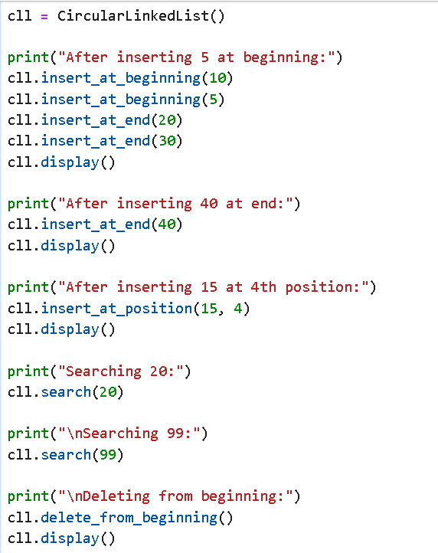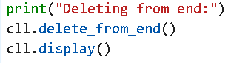

6. Sample Output
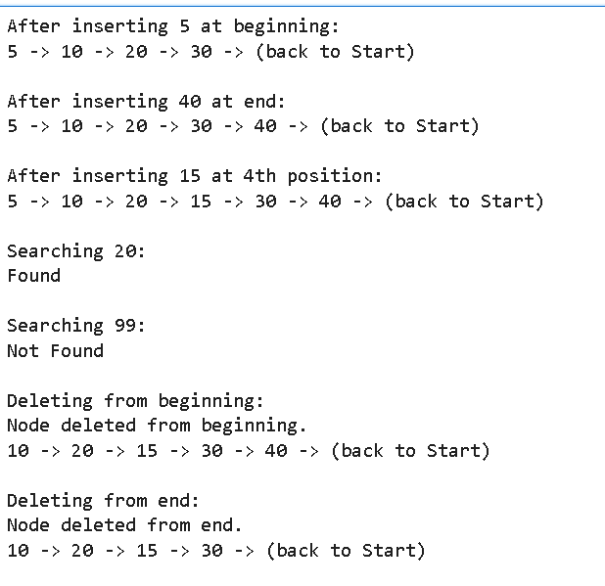

7. Time Complexities
Operation | Complexity
Insert (begin/end) | O(n)
Insert at position | O(n)
Delete (begin/end) | O(n)
Search | O(n)
Display | O(n)
8. Conclusion
This program clearly shows how a Circular Singly Linked List works by performing insertions, deletions, searching, and displaying elements while keeping the list connected in a loop. It demonstrates the flexibility of circular linked structures and how they allow continuous traversal without a natural end
.

LAB EXPERIMENT 05
Reverse a String Using Stack

1. Problem Statement
Write a Python program to reverse a string using the concept of stack.

2. Objective
• To understand how a stack operates using the LIFO (Last In, First Out) principle.
• To apply stack operations to reverse a given string.
• To demonstrate how pushing and popping characters can change the order of elements.
• To implement a simple stack-based solution in Python.
3. Description
A stack follows the LIFO rule, meaning the last element inserted is the first one removed.
To reverse a string using a stack, each character of the string is pushed onto the stack one by one.
When the characters are popped out, they come out in reverse order, forming the reversed string.
This approach highlights how stacks help in reversing sequences, undo operations, and parsing tasks.
4. Algorithm
Reverse String Using Stack
- Start with an empty stack.
- Read the input string from the user.
- Push each character of the string onto the stack.
- Pop characters one by one from the stack.
- Append each popped character to form the reversed string.
- Display the final reversed string.

5. Program Code
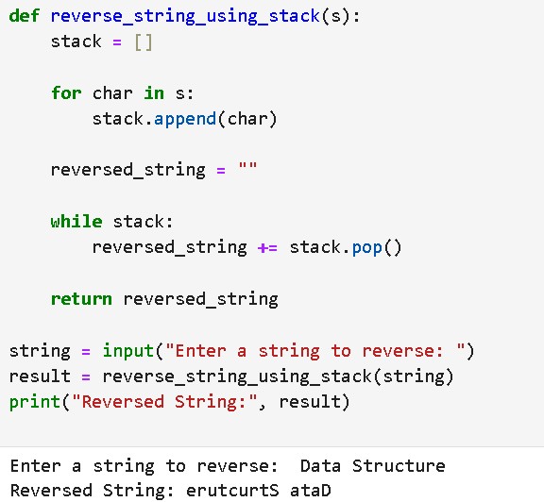

6. Sample Output

7. Conclusion
Reversing a string using a stack clearly shows how the LIFO principle works. By pushing all characters and then popping them out, we obtain the reversed form of the original string. This simple experiment helps understand stack behaviour and its real-world applications.

LAB EXPERIMENT 06
Check Balanced Parentheses Using Stack

1. Problem Statement
Write a Python program to check whether a given expression has balanced parentheses, including:
- ()
- []
- {}
The program should use the stack data structure to validate the expression.

2. Objective
- To understand how stacks help in validating expressions.
- To check whether parentheses — (), {}, [] — are properly balanced.
- To use push/pop operations to track opening and closing symbols.
- To ensure correct nesting and order of brackets in an expression.

3. Description
Balanced parentheses mean every opening bracket has a matching closing bracket in the correct order.
Using a stack, we scan the expression:
- Push opening brackets onto the stack.
- When a closing bracket appears, check if it matches the top of the stack.
- If all brackets match and the stack becomes empty at the end, the expression is balanced.
This method ensures correct syntax checking for mathematical and programming expressions.

4. Algorithm
Check Balanced Parentheses
- Initialize empty stack.
- For each character in expression:
  - If it's an opening bracket → push to stack.
  - If it's a closing bracket:
    - If stack empty → not balanced.
    - Check top of stack for matching bracket.
    - If matches → pop, else → not balanced.
- After traversal:
  - If stack empty → Balanced
  - Else → Not Balanced

5. Program Code
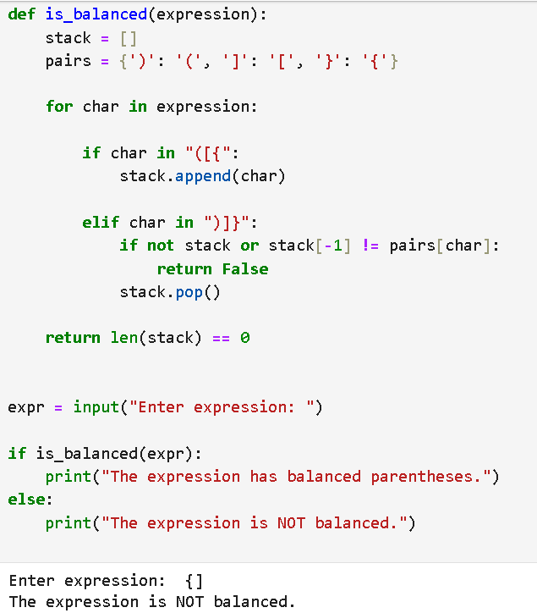

6. Sample Output

7. Conclusion
This program successfully checks balanced parentheses using a stack. By pushing opening brackets and matching them with closing ones, it shows how stack operations ensure correct nesting and ordering in expressions.

LAB PROJECT
Inventory Stock Management System

1. Problem Statement
Create a Python-based inventory management system that allows users to add, search, and delete products, check stock levels, track out-of-stock items, perform sales, and generate basic stock analytics like total, average, and maximum quantity.
2. Objective
- Develop a Python program with a menu interface to manage inventory efficiently.
- Utilize lists and dictionaries to organize and manipulate product data.
- Perform CRUD operations: adding, viewing, updating, and removing products.
- Analyse stock data to determine total inventory, average quantity, and highest stock levels.

3. Description
This program is designed to manage product details such as SKU, name, and quantity in an inventory system. Key features include:
- Maintaining all product records in a list called Inventory.
- Representing each product as a dictionary with keys for SKU, name, and quantity, e.g.,
{"sku": "P001", "name": "Pen", "quantity": 50}
- Providing modular functions to handle tasks such as adding new products, searching existing ones, deleting records, and checking stock levels.
- Offering a menu-driven interface that allows users to repeatedly select operations without restarting the program.
- Incorporating validation and exception handling to ensure smooth program execution.
- Including analytical tools for inventory management:
  - Detecting items with zero stock.
  - Calculating total and average stock.
  - Identifying products with the maximum stock.
  - Simulating sales, including normal transactions, insufficient stock situations, and out-of-stock scenarios.
This system provides a comprehensive and interactive solution for managing and analysing inventory in a practical, user-friendly manner.

4. Algorithm
A. Insert Product
- Ask number of products to be added.
- For each product:
  - Input SKU and check for duplicates.
  - Input valid product name.
  - Input quantity and ensure it’s a positive number.
  - Store product in inventory as a dictionary.
B. Search Product
- By SKU / By Name
- Input key (SKU or name).
- Traverse inventory.
- If matched, display product details.
C. Delete Product 30
- Supports both delete by SKU and delete by Name.
- Search inventory for match.
- Remove product if found.
D. Selling a Product
- Input SKU and quantity to sell.
- Check three conditions:
  - Quantity ≥ requested → normal sale
  - Quantity > 0 but less → insufficient stock
  - Quantity = 0 → zero stock
- Update inventory accordingly.
E. Check Zero Stock
- Loop through inventory.
- Display all items with quantity 0.
F. Total & Average Stock
- Total = sum of all quantities.
- Average = total / number of products.
G. Maximum Stock Item
- Find the highest quantity.
- Display all items that match that quantity.
H. Display Inventory
- Print all product details in tabular form.
I. Main Menu Loop
- Repeatedly show options 1–9
- Perform selected operation
- Exit when user chooses option 9 31

5. Program Code
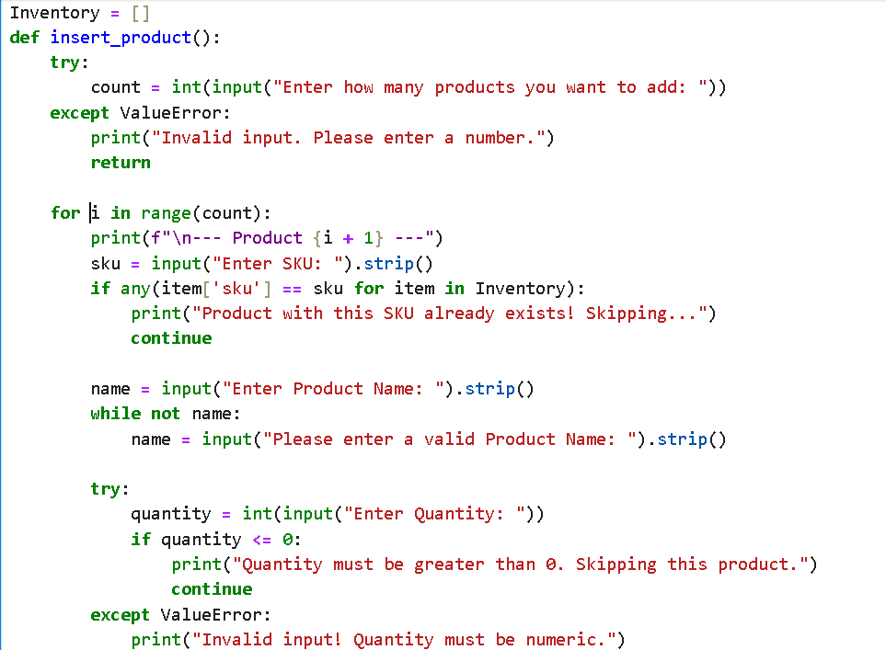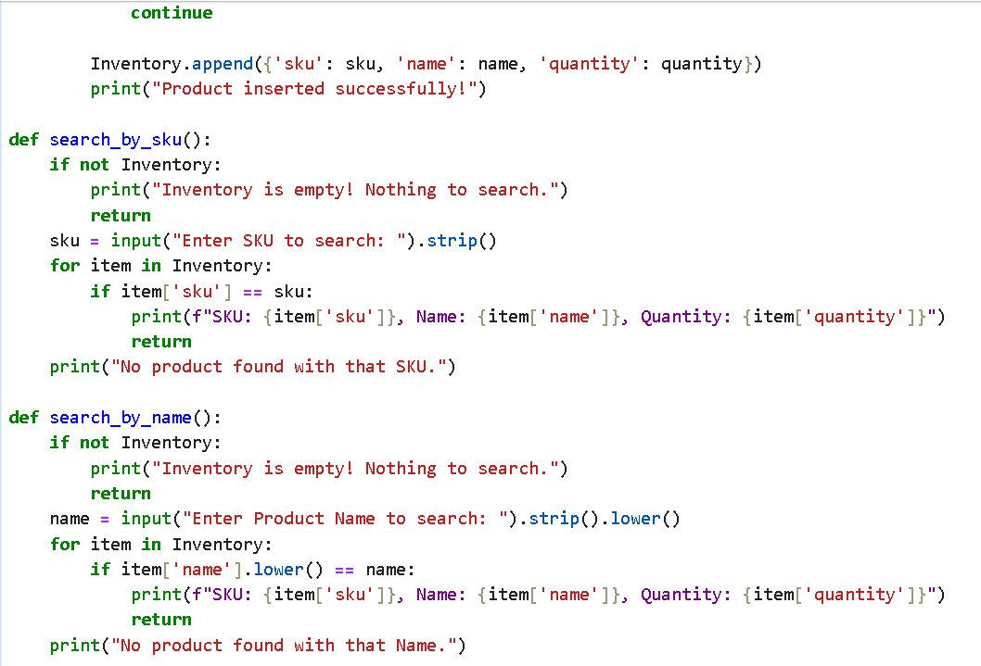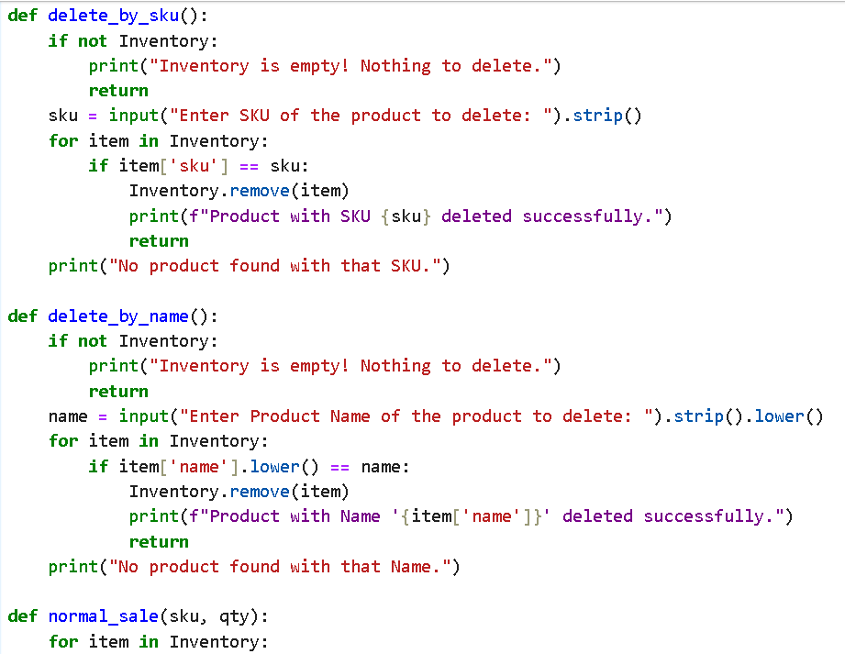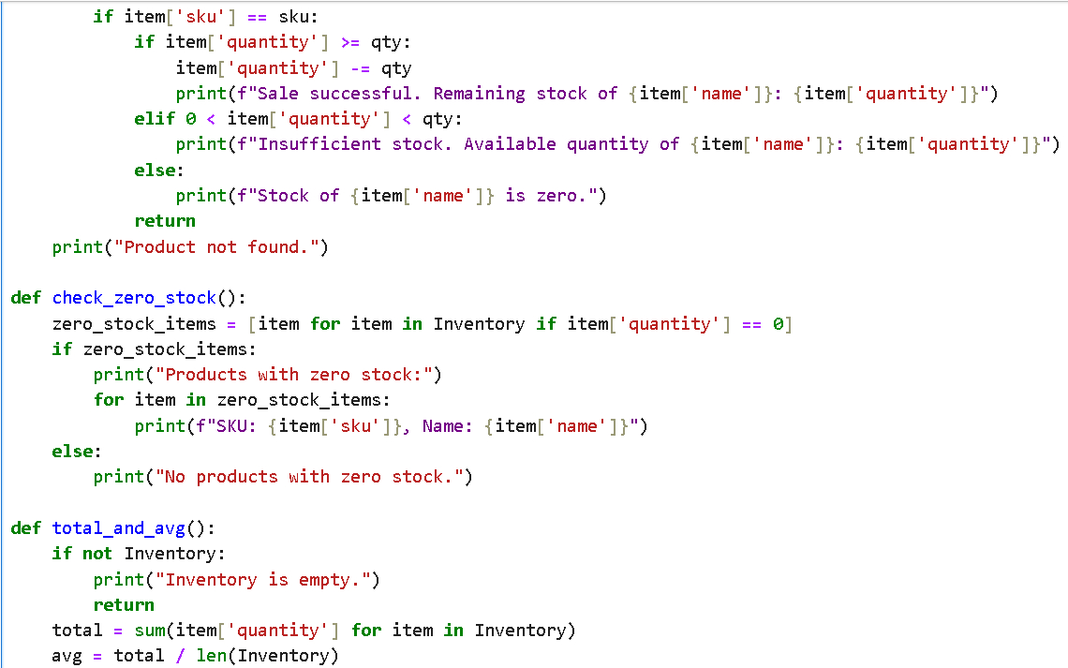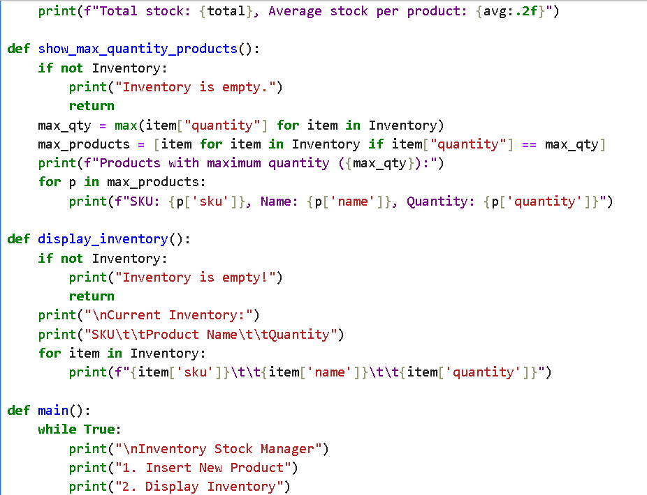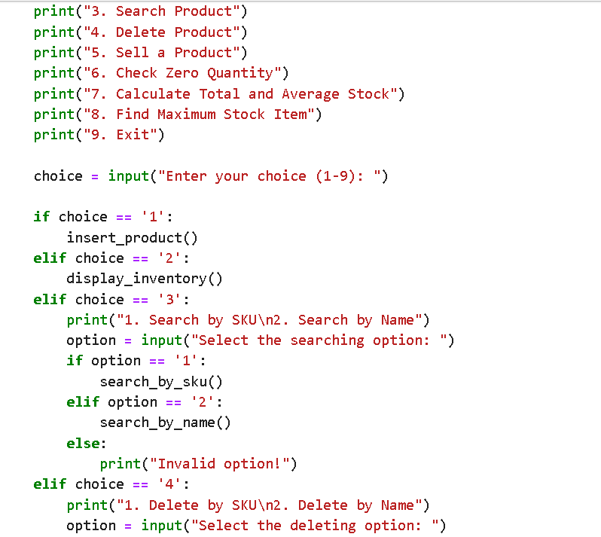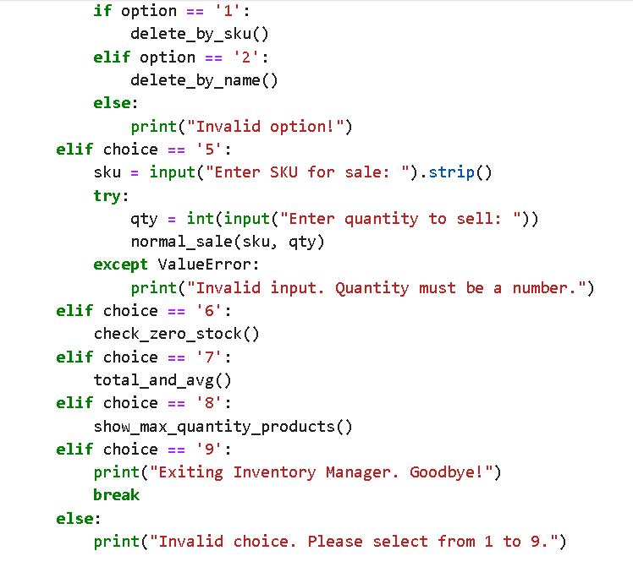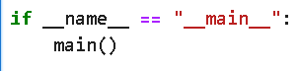

6. Sample Output
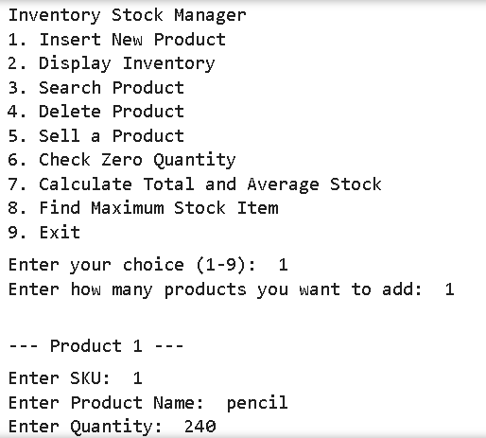
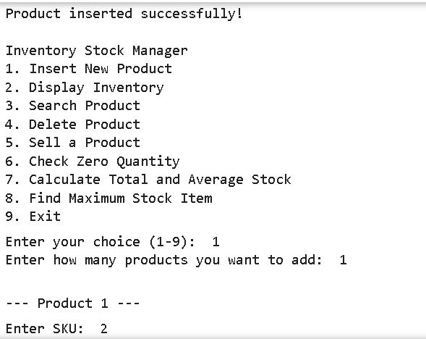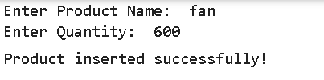
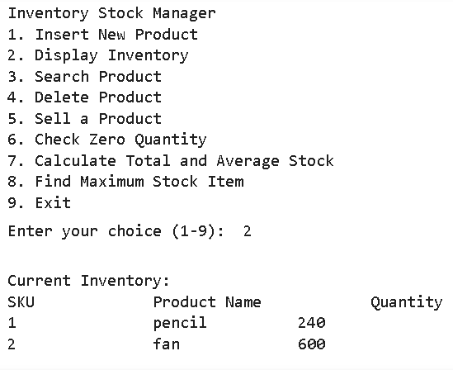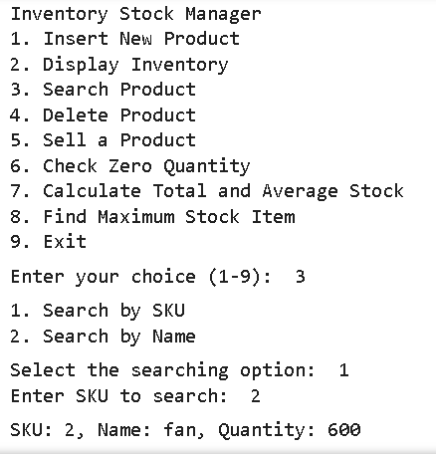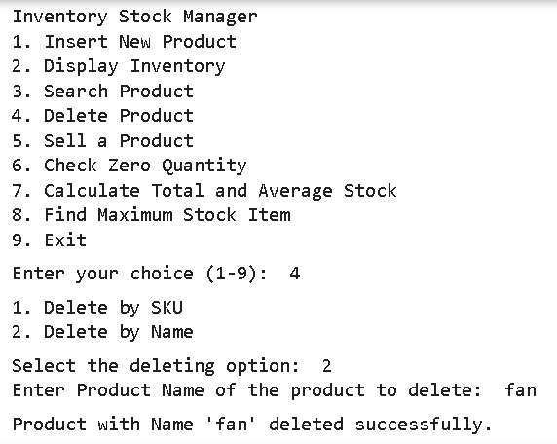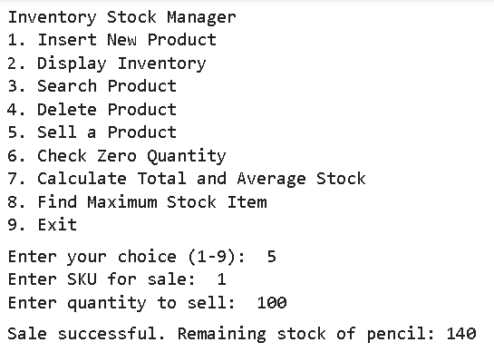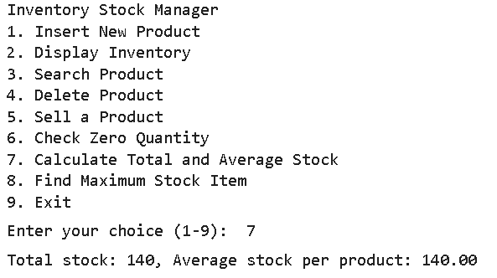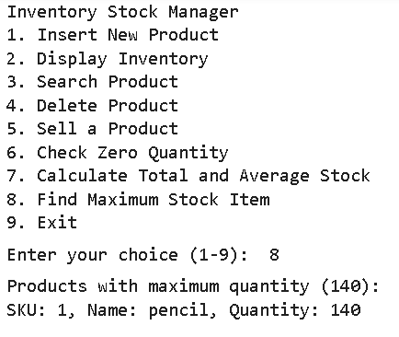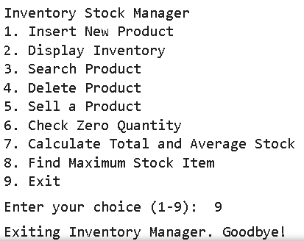

7. Time Complexity
Operation | Complexity
Insert | O(n)
Search (SKU/Name) | O(n)
Delete | O(n)
Sale | O(n)
Display | O(n)
Max Stock | O(n)

Benefits
- User-friendly, guided interface with a menu for easy navigation
- Ideal for beginners to understand and practice data structure concepts
- Provides insights into inventory with basic stock analytics
- Robust input handling prevents program crashes
Drawbacks
- Lacks persistent storage; all data is lost once the program ends
- Searching and deleting items is sequential, which can be slow for large inventories
Potential Improvements
- Implement file or database storage to preserve inventory data
- Enable editing or updating of existing product information
- Add features to sort products by name, quantity, or price
- Include automatic SKU/barcode generation for new products

7. Conclusion
This inventory management system effectively organizes and controls product data. It supports all key operations of a real-world inventory system, including adding, removing, searching, selling products, and performing stock analysis. The structured use of lists, dictionaries, functions, and exception handling ensures the program is both modular and reliable.

